**COMMUNIST PROGRAMMER’S PARTY**

Project Digitalization

**Game Design Document**

**Project Description**

Project Digitalization is a hybrid of an action and turn-based role-playing game set in a post-apocalyptic (and dystopian) world where a phenomenon called the Digitalization gave humanity God-like power that led to their slow and eventual demise.

The player takes control of two main party members where they will navigate the world in a third person perspective.

**Inspirations**

Inspirations may take shape in different forms, from music to shows. Even art direction can be an inspiration. Here are the media that inspired Project Digitalization:

**Mario & Luigi RPG series**

The Mario & Luigi RPG series is a sub-series of role-playing video games developed by AlphaDream and published by Nintendo. The series is a spin-off of the Mario Bros. franchise and features Mario and Luigi as the main playable characters.

Figure 1. Mario and Luigi Brothership Battle Gameplay

The games in the series are known for their unique blend of action-based combat and turn-based strategy, as well as their humorous writing and colorful visuals. The Mario & Luigi RPG series has received praise for its innovative game play, memorable casts, charming humor, as well as a few nods to Nintendo’s history.

Project Digitalization will be utilizing the timed-based battle mechanics of the Mario & Luigi RPG series for the main basis of the turn-based battle system. Normal attacks and the “Bros. Attacks” are used as a major reference. As for the flow of the battle system, certain aspects of it will be used in the project.

**The Legend of Heroes: Trails through Daybreak**

The Legend of Heroes: Trails through Daybreak is an action role-playing game by Nihon Falcom, marking the twelfth Trails series entry. Set in Calvard on the Zemurian continent, it features a mix of action and turn-based combat, letting players select their preferred battle system.

While primarily a turn-based game, the action battle system enables players to swiftly defeat enemies in seconds, circumventing lengthy turn-based encounters. Utilize the action battle system for weaker enemies, reserving turn-based combat for stronger foes (particularly bosses) to strategize and plan attacks effectively. You can change the battle system on-the-fly.

This will serve as Project Digitalization’s battle system flow.

Figure 2. Trials through Daybreak Turn-based Combat

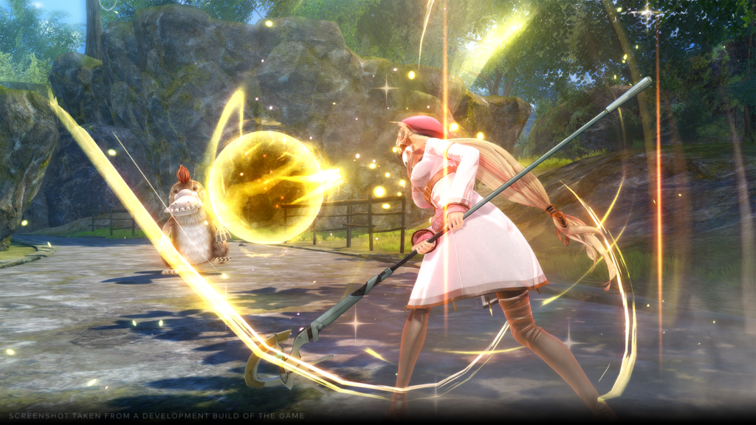

Figure 3. Trails through Daybreak Action Combat

**SCARLET NEXUS**

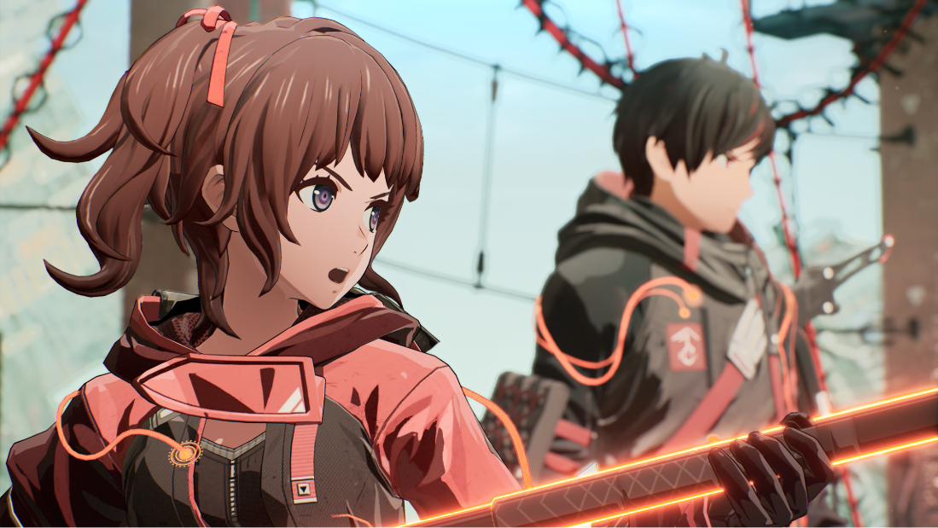

Figure 4. SCARLET NEXUS Cutscene Footage

SCARLET NEXUS is an action role-playing game developed and published by Bandai Namco Studios. The game is set in a futuristic “brain-punk” world where humanity is under attack from the Others, mysterious creatures that descended from the sky. Players take control of Yuito Sumeragi or Kasane Randall, new recruits of the Other Suppression Force (OSF), a military organization tasked with defending humanity from the Others.

The environments presented in SCARLET NEXUS will serve as a reference in Project Digitalization.

The music from SCARLET NEXUS will also serve as a reference for the music style for Project Digitalization. The use of chiptune as a lead instrument alongside rock, electronic, and orchestral instruments give a futuristic yet gamey vibes.

**Code Geass**

Code Geass is a highly acclaimed anime series created by Sunrise and directed by Gorō Taniguchi. The show is renowned for its intricate plot, complex characters, and its exploration of themes such as power, morality, and rebellion. Set in a dystopian future where global factions vie for control, Code Geass follows Lelouch vi Britannia, a young man with the power to control others, as he orchestrates a revolution against an oppressive empire while grappling with his own moral dilemmas.

Project Digitalization draws significant inspiration from Code Geass in several key aspects. The game mirrors the anime's focus on a morally complex protagonist with God-like powers, who must navigate a world torn apart by his and others' actions. Like Lelouch, Bastian, the game's main character, leads a powerful organization and faces the challenge of balancing personal ambition with the broader consequences of his actions. The game incorporates similar themes of power, control, and the ethical struggles associated with wielding immense abilities.

**Story**

The world is in chaos, torn apart by the misuse of Digitalization, a technology that grants humanity the power to create anything and bestow superhuman abilities upon themselves. Imperium Aeternum, a powerful organization, has taken control of Digitalization, enforcing its will on the shattered remnants of society. The Imperium played a crucial role in the event known as "The Shattering," a catastrophic moment when uncontrolled Digitalization led to the world's near-total destruction. They now rule the world with an iron fist, claiming to maintain order but often using their power for domination.

A weapon was created by a rogue faction to purge Digitalization from the world, believing that the only way to save humanity is to end the technology that has corrupted it. The Imperium seeks to control or destroy this weapon to prevent its use, as it would threaten their power.

The once-leader of Imperium Aeternum, Bastian was instrumental in the organization’s rise to power. After losing his memory during a rebel ambush, Bastian now unknowingly fights against his former comrades as he slowly regains his memories and discovers the truth about his past. As Bastian navigates the war-torn world, he encounters many faces both friend and foe alike on his journey, he must decide whether to reclaim his position within Imperium Aeternum, destroy the weapon to maintain their control, or activate it to end Digitalization, even if it means the end of the world.

**Battle Gameplay**

This section aims to integrate a seamless transition between an action-based and turn-based combat system while incorporating timed-based attacks. The objective is to create a unique, immersive battle experience that combines the strategic depth of turn-based combat with the fast-paced, reflex-driven action found in real-time systems. This hybrid system will emphasize player skill and decision-making while maintaining the traditional tactical elements of turn-based gameplay.

**Action-based Combat with Free Control**

* **Exploration Phase** - While exploring the world, battle starts in real-time action mode. The player controls the main character and can engage in minor skirmishes with enemies directly on the field.
* **Dynamic Combat Shift** - Upon engaging tougher enemies or bosses, the battle can smoothly transition into a turn-based mode after one of the characters was able to stun an enemy, or when the player chooses to initiate "Tactical Mode." This shift will occur dynamically without loading screens or hard stops, maintaining immersion.
* **Situational Awareness -** Players can opt to **enter turn-based combat manually** or continue fighting in real-time for weaker enemies, blending styles based on tactical needs or personal preference.

**Turn-based Combat with Timed-based Attacks**

* **Action Commands** - During the turn-based combat, player can execute timed attacks and defense attacks like the mechanics in Mario & Luigi RPG series.
  + **Timed Attack Inputs** - Pressing a button dedicated to one of the characters at the right moment will grant the characters additional benefits such as dealing more damage or chaining multiple attacks.
    - **Timed Defense Inputs** - Pressing a button dedicated to one of the characters at the right moment during an enemy’s attack phase will allow the characters to dodge the attack or even counterattack.
* **Special Skills** - Unique abilities can also involve quick-time events (**QTEs**) where precise inputs from involved characters during an animation enhances the move’s effects.
* **Character Synergy** - Certain characters can have group or combo attacks which also involve timed inputs from the involved characters, rewarding teamwork with more powerful moves when executed correctly.

**Action Momentum & Tactical Planning**

* **Momentum System** - The system will feature a momentum gauge that builds up during the action phase. This gauge carries over into turn-based combat, allowing players to use it as a resource for special moves, combos, or powerful group attacks when transitioning to a turn-based battle.
* **Action Influence on Turn-Based Combat** - Decisions made during the action phase can affect the flow of the subsequent turn-based battle. Factors such as weakening the enemy and team positioning may bring advantages and even disadvantages during battle.

**Hybrid Battle UI & Feedback**

* **On-Screen Indicators** - The battle HUD will adapt dynamically depending on whether the player is in action or turn-based combat. In real-time combat, an action bar will appear that shows cooldowns, stamina, and available skills, while in turn-based combat, it will switch to show turn order and command menus.
* **Audio and Visual Cues** - Timing for action-based attacks will be highlighted by visual and audio cues, making it intuitive for players to engage with timed inputs while also giving the enemies some personality.